232转485接线说明

DB9的RX接主机232口的RX，DB9的TX接主机232口的TX，DB9的GND接主机232口的GND。
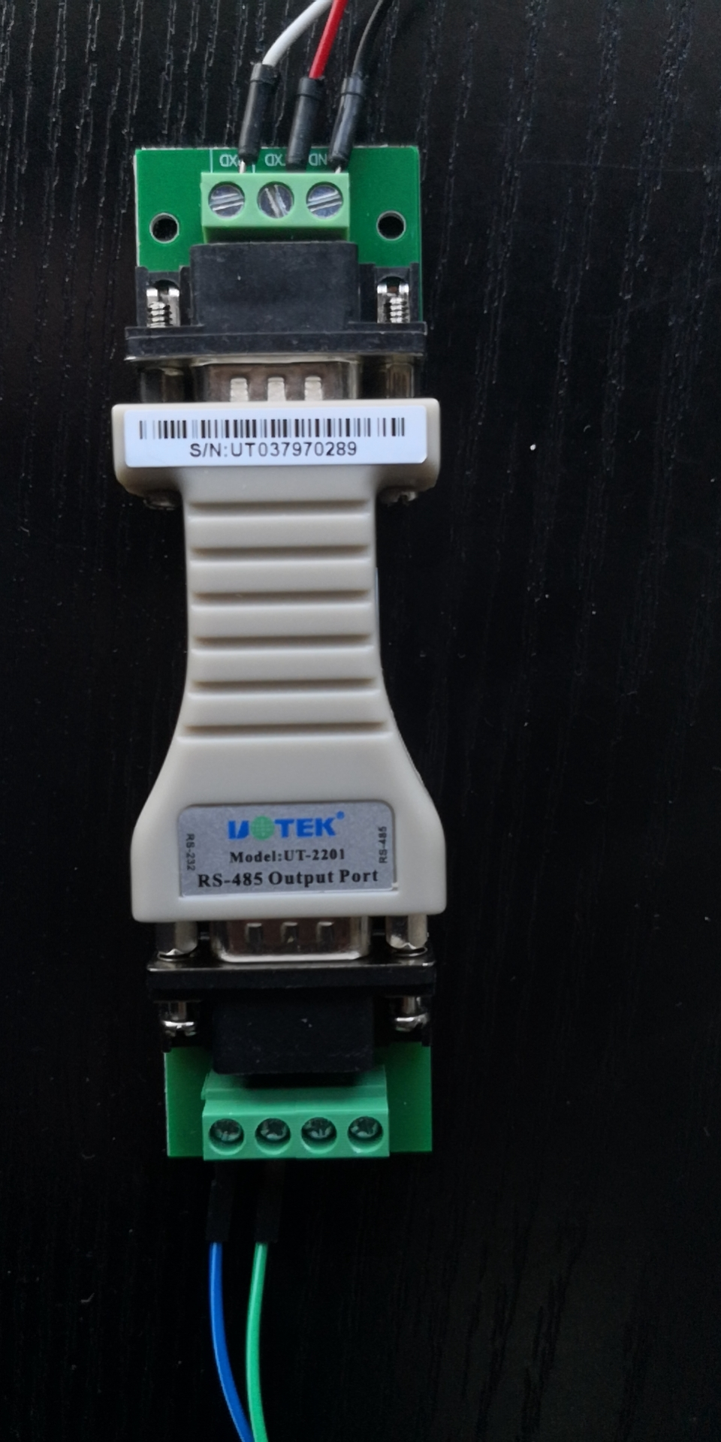

UT2201购买链接
https://detail.tmall.com/item.htm?id=20025722564&spm=a1z09.2.0.0.35192e8dVCPsET&_u=m85bqa84d09
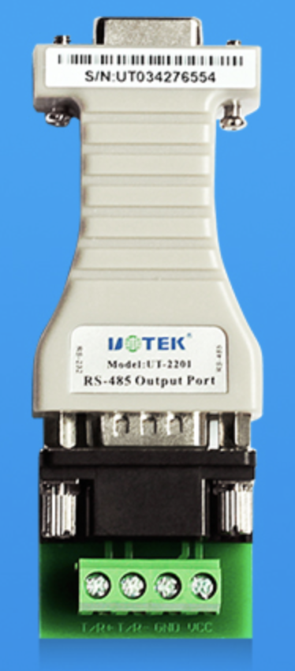

DT-9000购买链接
https://detail.tmall.com/item.htm?id=536979196464&spm=a1z09.2.1997525049.3.35be2e8dtVUen0
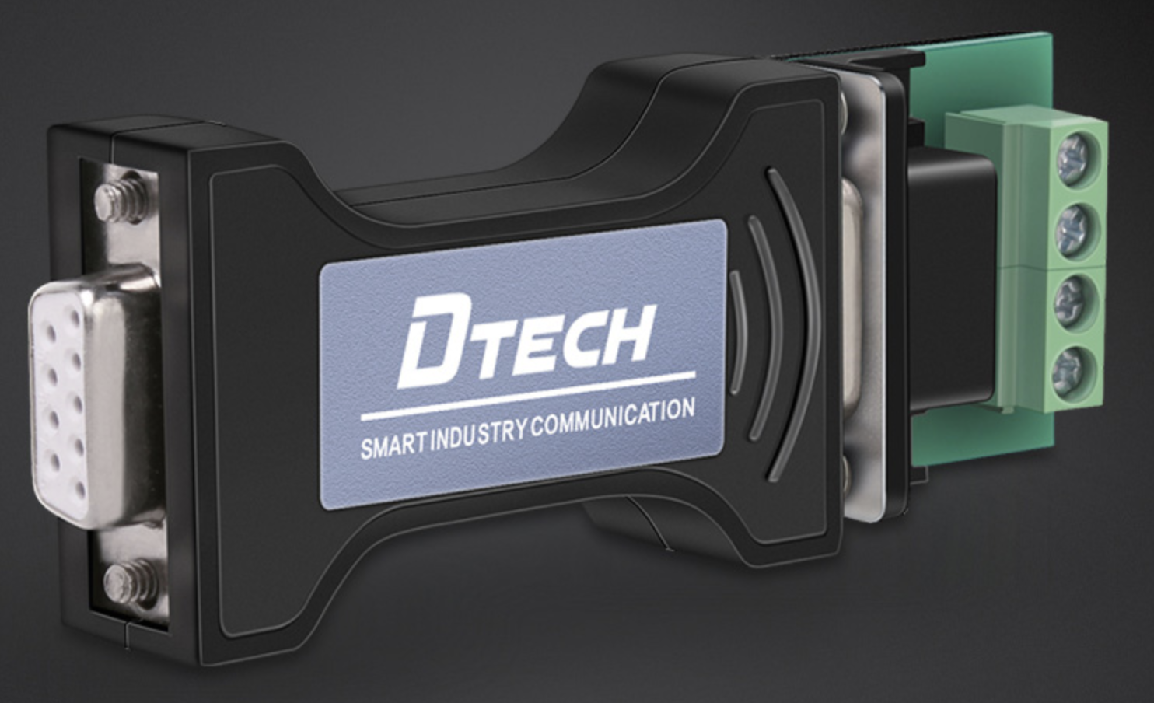

DB9接线柱(公头螺母式)购买链接
https://detail.tmall.com/item.htm?id=525412860013&spm=a1z09.2.0.0.35192e8dVCPsET&_u=m85bqa85d25
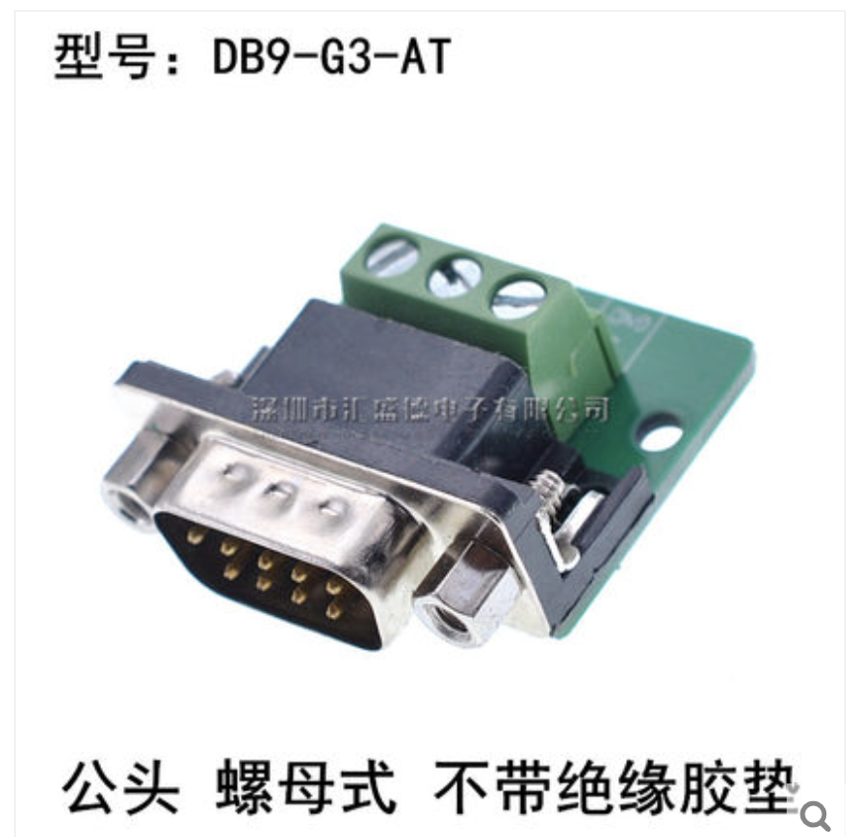

标准DB9公母头线序
